# Durable Furnitures

Artistica

## Contemporary Craftsman Mirror

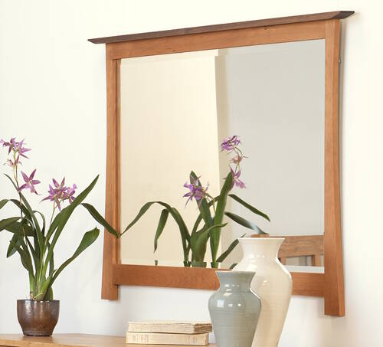

Our Contemporary Craftsman large, wood framed accent mirror features a beautiful solid cherry or maple frame with a gentle arch, walnut cap piece and fine detailing. This mirror works great as an accent mirror over your dresser, sideboard, hall table or anywhere you need to make that extra statement. Made in Vermont by fine furniture makers using premium quality sustainably harvested wood with an eco-friendly oil finish.